AIM

Application Functional Design

EETDB DB Specification

Programme: UNIDO EETDB

Author: Nikolay Komissarenko

Creation Date: 29 April 2013

Last Updated: 29 April 2013

Version: 1.0

1. **Title, Subject, Last Updated Date, Reference Number**, **and** **Version** are marked by a Word Bookmark so that they can be easily reproduced in the header and footer of documents. When you change any of these values, be careful not to accidentally delete the bookmark. **You can make bookmarks visible by selecting Tools->Options…View and checking the Bookmarks option in the Show region.**

**Approvals:**

|  |  |
| --- | --- |
| TBD |  |
| TBD |  |
| TBD |  |

1. To add additional approval lines, press [Tab] from the last cell in the table above.
2. You can delete any elements of this cover page that you do not need for your document. For example, Copy Number is only required if this is a controlled document and you need to track each copy that you distribute.

## Document Control

Change Record

| Date | Author | Version | Change Reference |
| --- | --- | --- | --- |
|  |  |  |  |
| 29 April 2013 | Nikolay Komissarenko | 1.0 | draft |
|  |  |  |  |

Reviewers

| Name | Position |
| --- | --- |
|  |  |
|  | Approver |
|  | Reviewer |
|  | Approver |

1. The copy numbers referenced above should be written into the **Copy Number** space on the cover of each distributed copy. If the document is not controlled, you can delete this table, the Note To Holders, and the **Copy Number** label from the cover page.

References

| Document Title | Description | Owner | Location |
| --- | --- | --- | --- |
|  |  |  |  |
|  |  |  |  |
|  |  |  |  |
|  |  |  |  |
|  |  |  |  |

### Contents

Document Control ii

Contents iv

Overview ii

Definitions ii

Assumptions ii

Basic Needs iii

Current state iii

Common requirements iii

EETDB Data Access Services requirements iii

EETDB Data Access Services architecture iv

EETDB API vi

Data Access Layer viii

Configuration xii

Deployment xiv

Open and Closed Issues for this Deliverable xv

Open Issues xv

Closed Issues xv

Appendix A xvi

1. To update the table of contents, put the cursor anywhere in the table and press [F9]. To change the number of levels displayed, select the menu option Insert‑>Index and Tables, make sure the Table of Contents tab is active, and change the Number of Levels to a new value.

## Overview

### Definitions

EETDB – Energy Efficient Technologies Data Bank

UNIDO – United Nations Industrial Development Organization

### Assumptions

1. EETDB is not a standalone web-enabled system, it’s part of the UNIDO web site <http://energy.unido.ru/>
2. If you use a user-friendly name for this customization as the replacement for <Subject>, the following paragraphs will default nicely.

## Basic Needs

### EETDB Database requirements

Database is part of EETDB solution. It is aimed to provide safe physical data storage with easy way to store/get data and fast search through the data.

The main entities that are supposed to be stored in EETDB Database are

* lists of classification headings,
* energy saving equipments with characteristics,
* descriptions of energy saving technologies.

Database is designed to be used by EETDB Data Access Services.

## EETDB Database architecture

The EETDB Database has the relational structure described by the following schema:

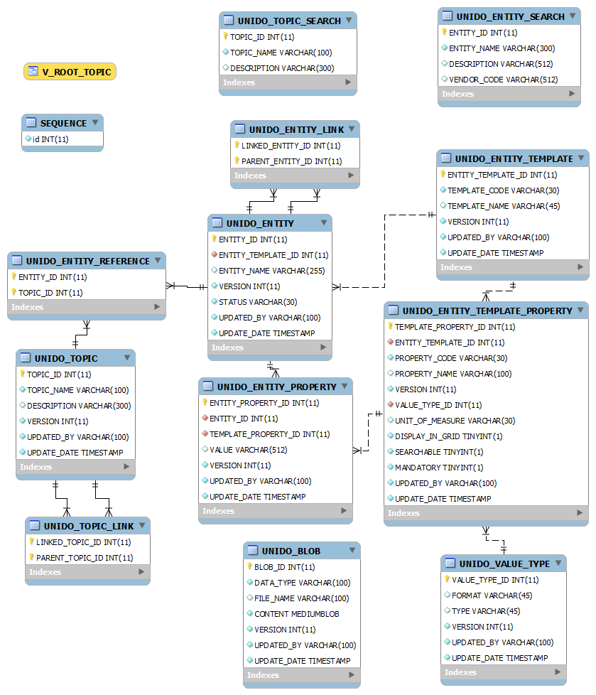

## EETDB Database Tables

EETDB Database tables have the common audit strategy realized by VERSION, UPDATED_BY, UPDATE_DATE columns added in the main tables. These fields provide the clear view on the changes performed on the records.

EETDB Database has the following tables.

#### UNIDO_TOPIC

UNIDO_TOPIC table is used to store the lists of classification headings.

|  |  |  |  |
| --- | --- | --- | --- |
| **Column name** | **Column type** | **Can be empty** | **Description** |
| TOPIC_ID | INT | No | Unique identifier of classification heading. *Primary key*. |
| TOPIC_NAME | NVARCHAR(100) | No | Name of classification heading. |
| DESCRIPTION | NVARCHAR(300) | Yes | Detailed description of classification heading. |
| VERSION | INT | No | Version number of classification heading. Auto incremented with update operation. *Audit field.* |
| UPDATED_BY | NVARCHAR(100) | No | NT Login of user performed the operation. *Audit field.* |
| UPDATE_DATE | TIMESTAMP | No | Date of the operation. *Audit field.* |

#### UNIDO_TOPIC_LINK

All the classification headings of EETDB can be combined in several heading trees. UNIDO_TOPIC_LINK table is used to store the relationships between the headings.

|  |  |  |  |
| --- | --- | --- | --- |
| **Column name** | **Column type** | **Can be empty** | **Description** |
| PARENT_TOPIC_ID | INT | No | Parent heading ID from UNIDO_TOPIC |
| LINKED_TOPIC_ID | INT | No | Child heading ID from UNIDO_TOPIC |

#### UNIDO_ENTITY_TEMPLATE

UNIDO_ENTITY_TEMPLATE is a table used to store the templates of the EETDB Database entities. Each row in this table describes the type of equipment or technology.

|  |  |  |  |
| --- | --- | --- | --- |
| **Column name** | **Column type** | **Can be empty** | **Description** |
| ENTITY_TEMPLATE_ID | INT | No | Unique identifier of entity. *Primary key*. |
| TEMPLATE_CODE | NVARCHAR(30) | No | Unique code of template. Used in the upload-file. |
| TEMPLATE_NAME | NVARCHAR(45) | No | Name of the template. Used in UI. |
| VERSION | INT | No | Version number of template. Auto incremented with update operation. *Audit field.* |
| UPDATED_BY | NVARCHAR(100) | No | NT Login of user performed the operation. *Audit field.* |
| UPDATE_DATE | TIMESTAMP | No | Date of the operation. *Audit field.* |

#### UNIDO_ENTITY_TEMPLATE_PROPERTY

UNIDO_ENTITY_TEMPLATE_PROPERTY is a table used to store the properties of the EETDB Database template. Each row in this table describes some characteristic of equipment or technology.

|  |  |  |  |
| --- | --- | --- | --- |
| **Column name** | **Column type** | **Can be empty** | **Description** |
| TEMPLATE_PROPERTY_ID | INT | No | Unique identifier of property. *Primary key*. |
| ENTITY_TEMPLATE_ID | INT | No | Identifier of corresponding template. *Primary key*. |
| PROPERTY_CODE | NVARCHAR(30) | No | Code of property. Code is unique within template properties. |
| PROPERTY_NAME | NVARCHAR(100) | No | Name of the property. |
| VALUE_TYPE_ID | INT | No | Type of the characteristic value. ID from the table UNIDO_VALUE_TYPE. |
| UNIT_OF_MEASURE | NVARCHAR(30) | Yes | Unit of measure of characteristic, if applicable. |
| DISPLAY_IN_GRID | TINYINT(1) | No | Flag showing if UI should show this characteristic in the table. |
| SEARCHABLE | TINYINT(1) | No | Flag showing if UI can provide the search functionality by this characteristic. |
| MANDATORY | TINYINT(1) | No | Flag showing if the characteristic must have the value for all entity or could be left empty. |
| VERSION | INT | No | Version number of property. Auto incremented with update operation. *Audit field.* |
| UPDATED_BY | NVARCHAR(100) | No | NT Login of user performed the operation. *Audit field.* |
| UPDATE_DATE | TIMESTAMP | No | Date of the operation. *Audit field.* |

#### UNIDO_ENTITY

UNIDO_ENTITY is a main table used to store the list of equipments and technologies.

Each row in this table realizes some template described in the table UNIDO_ENTITY_TEMPLATE.

|  |  |  |  |
| --- | --- | --- | --- |
| **Column name** | **Column type** | **Can be empty** | **Description** |
| ENTITY_ID | INT | No | Unique identifier of entity. *Primary key*. |
| ENTITY_TEMPLATE_ID | INT | No | Identifier of template that the entity realizes. ID from the table UNIDO_ENTITY_TEMPLATE |
| ENTITY_NAME | NVARCHAR(255) | No | Name of the entity. |
| STATUS | NVARCHAR(30) | No | State of entity. Can take the following values: ‘PENDING’ – loaded but not processed yet so not available in the catalog, ‘CERTIFIED’ – available in catalog and certified,  ‘NOT CERTIFIED’ – available in catalog but not certified |
| VERSION | INT | No | Version number of entity. Auto incremented with update operation. *Audit field.* |
| UPDATED_BY | NVARCHAR(100) | No | NT Login of user performing the operation. *Audit field.* |
| UPDATE_DATE | TIMESTAMP | No | Date of the operation. *Audit field.* |

#### UNIDO_ENTITY_REFERENCE

All the entity of EETDB Database can be related to several classification headings from heading tree. UNIDO_ENTITY_REFERENCE table is used to store the relationships between the entities and headings.

|  |  |  |  |
| --- | --- | --- | --- |
| **Column name** | **Column type** | **Can be empty** | **Description** |
| ENTITY_ID | INT | No | Entity ID |
| TOPIC_ID | INT | No | Heading ID from UNIDO_TOPIC |

#### UNIDO_ENTITY_LINK

All the entity of EETDB Database can be related to other entities. UNIDO_ENTITY_LINK table is used to store the relationships between the entities.

|  |  |  |  |
| --- | --- | --- | --- |
| **Column name** | **Column type** | **Can be empty** | **Description** |
| PARENT_ENTITY_ID | INT | No | Parent entity ID from UNIDO_ENTITY |
| LINKED_ENTITY_ID | INT | No | Child entity ID from UNIDO_ENTITY |

#### UNIDO_ENTITY_PROPERTY

UNIDO_ENTITY_PROPERTY table is used to store the characteristics of equipments and technologies. Each row in this table set the value of some characteristic of the entity template described in the table UNIDO_ENTITY_TEMPLATE_PROPERTY.

|  |  |  |  |
| --- | --- | --- | --- |
| **Column name** | **Column type** | **Can be empty** | **Description** |
| ENTITY_PROPERTY_ID | INT | No | Unique identifier of property value. *Primary key*. |
| ENTITY_ID | INT | No | Link to corresponding entity. ID from UNIDO_ENTITY table. |
| TEMPLATE_PROPERTY_ID | INT | No | Link to template property that the value is set for. ID from UNIDO_ ENTITY_TEMPLATE_PROPERTY table. |
| VALUE | NVARCHAR(512) | No | The value of characteristic. All the values are represented as a string. |
| VERSION | INT | No | Version number of the characteristic value. Auto incremented with update operation. *Audit field.* |
| UPDATED_BY | NVARCHAR(100) | No | NT Login of user performing the operation. *Audit field.* |
| UPDATE_DATE | TIMESTAMP | No | NT Login of user performing the operation. *Audit field.* |

#### UNIDO_VALUE_TYPE

UNIDO_VALUE_TYPE table is used as a dictionary of the types of the entity characteristics values. Each row in this table describes the value type, its format and determines the way to proceed with the values of the type.

|  |  |  |  |
| --- | --- | --- | --- |
| **Column name** | **Column type** | **Can be empty** | **Description** |
| VALUE_TYPE_ID | INT | No | Unique identifier of value type. *Primary key*. |
| FORMAT | NVARCHAR(45) | No | Format of the value type. If applicable. |
| TYPE | NVARCHAR(45) | No | Name of the value type. |
| VERSION | INT | No | Version number of the characteristic value. Auto incremented with update operation. *Audit field.* |
| UPDATED_BY | NVARCHAR(100) | No | NT Login of user performing the operation. *Audit field.* |
| UPDATE_DATE | TIMESTAMP | No | NT Login of user performing the operation. *Audit field.* |

There are several types predefined in the system:

|  |  |  |
| --- | --- | --- |
| **Type name** | **Format** | **Description** |
| STRING |  | simple string up to 512 characters. |
| TEXT |  | long text. Value can be flat text or HTML. Value is stored in UNIDO_BLOB. |
| NUMBER | 2 | decimal number with 2 decimal digits. |
| INTEGER |  | integer number. |
| BOOLEAN |  | Boolean value that can be true or false. |
| URL | URL | link to some web-page, image or document. |
| REFERENCE | ENTITY_ID | the reference to the lookup value. All the lookups are stored in the EETDB Database as the entities without properties. The value of this type should be ENTITY_ID of selected lookup’s element. |
| FILE | BINARY | The file uploaded to the system and available to be downloaded in the UI. Value should contain the valid ID from UNIDO_BLOB table. |
| IMG | BINARY | The image uploaded to the system and available to be shown in the UI. Value should contain the valid ID from UNIDO_BLOB table. |

#### UNIDO_BLOB

UNIDO_BLOB table is used as the data storage for the uploaded texts, files and images. Each record of this table can be referenced from UNIDO_ENTITY_PROPERTY table.

|  |  |  |  |
| --- | --- | --- | --- |
| **Column name** | **Column type** | **Can be empty** | **Description** |
| BLOB_ID | INT | No | Unique identifier of value type. *Primary key*. |
| DATA_TYPE | NVARCHAR(100) | No | Type of the data that are stored in the record. (encoding for html, format for images) |
| FILE_NAME | NVARCHAR(100) | Yes | Name of the uploaded file or image. |
| CONTENT | MEDIUMBLOB | No | Binary data. |
| VERSION | INT | No | Version number of the file. Auto incremented with update operation. *Audit field.* |
| UPDATED_BY | NVARCHAR(100) | No | NT Login of user performing the operation. *Audit field.* |
| UPDATE_DATE | TIMESTAMP | No | NT Login of user performing the operation. *Audit field.* |

#### UNIDO_TOPIC_SEARCH

All the entities of EETDB Database have some characteristics that can be used in full text search procedure to find the required equipment, article or classification heading. UNIDO_TOPIC_SEARCH table is used to store the searchable field of the classification headings. The records are managed automatically by the special triggers. The table is used in the procedure SEARCH_TOPIC.

|  |  |  |  |
| --- | --- | --- | --- |
| **Column name** | **Column type** | **Can be empty** | **Description** |
| TOPIC_ID | INT | No | Identifier of classification heading. ID from UNIDO_TOPIC. |
| TOPIC_NAME | NVARCHAR(100) | No | Name of classification heading. NAME from UNIDO_TOPIC. |
| DESCRIPTION | NVARCHAR(300) | Yes | Description of classification heading. DESCRIPTION from UNIDO_TOPIC |

#### UNIDO_ ENTITY_SEARCH

All the entities of EETDB Database have some characteristics that can be used in full text search procedure to find the required equipment, article or classification heading. UNIDO_ ENTITY_SEARCH table is used to store the searchable field of the entities. The records are managed automatically by the special triggers. The table is used in the procedure SEARCH.

|  |  |  |  |
| --- | --- | --- | --- |
| **Column name** | **Column type** | **Can be empty** | **Description** |
| ENTITY_ID | INT | No | Identifier of the entity. ID from UNIDO_ENTITY. |
| ENTITY_NAME | NVARCHAR(300) | No | Name of the entity. NAME from UNIDO_ENTITY. |
| DESCRIPTION | NVARCHAR(512) | Yes | Description of the entity. VALUE from UNIDO_ENTITY_PROPERTY where the property name is ‘DESCRIPTION’. |
| VENDOR_CODE | NVARCHAR(512) | Yes | Original equipment code (SKU) of the equipment in the vendor’s catalog. VALUE from UNIDO_ENTITY_ PROPERTY where the property name is ‘VENDOR_CODE’. |

#### SEQUENCE

All the entities of EETDB Database have unique identifier. To provide uniqueness of these identifier there is a special table SEQUENCE in the EETDB Database. This table store the last used ID. The special function SEQ_NEXTVAL increment this value and returns the next identifier each time that is being called.

|  |  |  |  |
| --- | --- | --- | --- |
| **Column name** | **Column type** | **Can be empty** | **Description** |
| ID | INT | No | Identifier. |

## EETDB Database Triggers

The triggers are only used in EETDB Database to populate the tables with the searchable data. There are two triggers.

#### ADD_TOPIC_SEARCH

This trigger populates the records in the table TOPIC_SEARCH by inserting/updating/deleting according to the operation performed on the UNIDO_TOPIC table.

|  |  |  |  |
| --- | --- | --- | --- |
| **Trigger name** | **Action** | **Table** | **Description** |
| ADD_TOPIC_SEARCH | INSERT | UNIDO_TOPIC | Inserts the record to the table TOPIC_SEARCH with the same values as inserted in the original table. |
| UPDATE_TOPIC_SEARCH | UPDATE | UNIDO_TOPIC | Update the record with the same ID in the table TOPIC_SEARCH with the same values (NAME, DESCRIPTION) as updated in the original table. |
| DELETE_TOPIC_SEARCH | DELETE | UNIDO_TOPIC | Delete the record with the same ID from the table TOPIC_SEARCH. |

## Data Access Layer

Data access interface provides CRUD and data search methods as follows:

## Configuration

There are three main configuration files for DAS:

#### Logging

Logging in provided via Log4j and configured via log4j.properties file located in WebContent/WEB-INF/classes folder.

## Deployment

DAS is distributed in a web archive (WAR) file. Deployment of DAS is a standard procedure for WARs – the file should be copied in to the Tomcat webapp/ folder and then it will get installed by the server.

After the installation is complete it can be required to update DAS config files (ref:Configuration).

## Open and Closed Issues for this Deliverable

1. **Define Auto Cash Rules:** Dell Prepaid Rule, Dell Standard RuleAdd open issues that you identify while writing or reviewing this document to the open issues section. As you resolve issues, move them to the closed issues section and keep the issue ID the same. Include an explanation of the resolution.  
     
   When this deliverable is complete, any open issues should be transferred to the project- or process-level Risk and Issue Log (PJM.CR.040) and managed using a project level Risk and Issue Form (PJM.CR.040). In addition, the open items should remain in the open issues section of this deliverable, but flagged in the resolution column as being transferred.

### Open Issues

|  |  |  |  |  |  |  |
| --- | --- | --- | --- | --- | --- | --- |
|  |  |  |  |  |  |  |
|  |  |  |  |  |  |  |
|  |  |  |  |  |  |  |
|  |  |  |  |  |  |  |
|  |  |  |  |  |  |  |
|  |  |  |  |  |  |  |
|  |  |  |  |  |  |  |
|  |  |  |  |  |  |  |
|  |  |  |  |  |  |  |

### Closed Issues

| ID | Raised by | Issue | Resolution | Owner | Target Date | Impact Date |
| --- | --- | --- | --- | --- | --- | --- |
|  |  |  |  |  |  |  |
| 1 | Artem |  |  |  |  |  |
|  |  |  |  |  |  |  |
|  |  |  |  |  |  |  |
|  |  |  |  |  |  |  |
|  |  |  |  |  |  |  |
|  |  |  |  |  |  |  |

## Appendix A